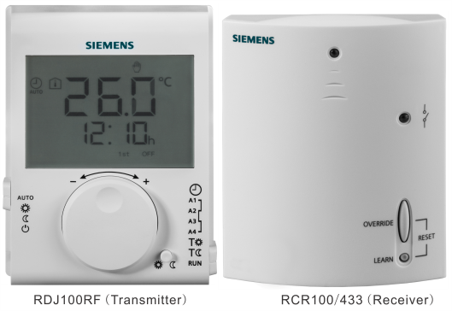 | - Room thermostat with LCD and scheduler program  - TPI control  - RF set, thermostat with LCD for heating systems, radiators, floor heating for the control of thermal valves, gas or oil boilers or pumps  - Consisting of thermostat transmitter battery-powered by DC 3 V and thermostat receiver mains-powered by AC 230 V

Plant diagram
Plant diagram | 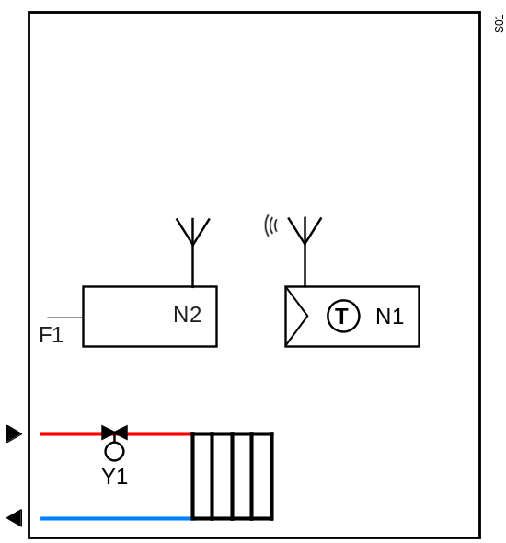

 | 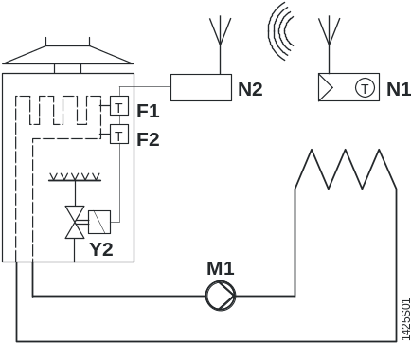 |  | 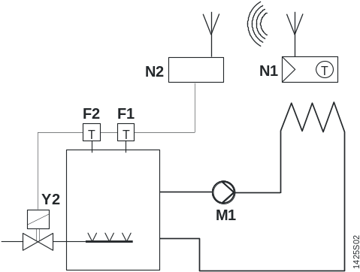
 | Room thermostat with direct control  of a gas-fired wall-hung boiler |  | Room thermostat with direct control  of a gas-fired floor-standing boiler
 | 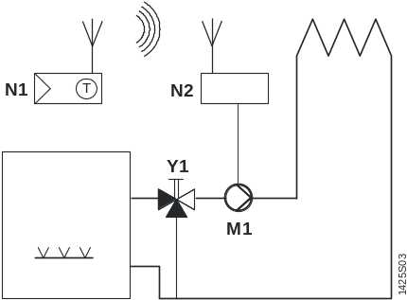 |  | 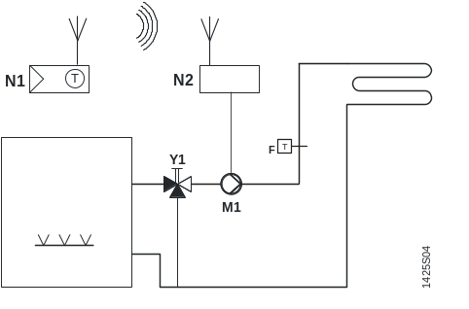
 | Room thermostat with direct control of a heating circuit pump (pre-control by manual mixing valve) |  | Room thermostat with direct control  of a hydronic floor heating system

 | F1 | Thermal reset limit thermostat |  | N1 | Room thermostat transmitter
 | F2 | Safety limit thermostat |  | N2 | Room thermostat receiver
 | M1 | Circulating pump |  | Y1 | 3-port valve with manual adjustment
 |  |  |  | Y2 | Magnetic valve

Function  diagram | Heating
Function  diagram | 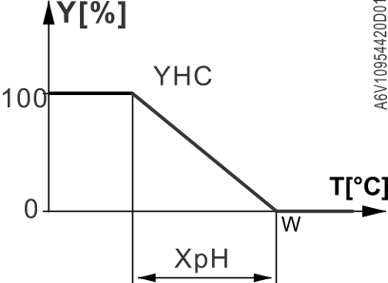
 | T | Room temperature |  | Y | Output signal for “Heating” (PWM)
 | XpH | Proportional band “Heating” |  | YHC | Control command “Valve”
 | w | Room temperature setpoint

Description  of functions | Sequence |  | Setpoint adjustment
Description  of functions | - TPI (PWM) control |  | - Locally on room thermostat - Turning Knob
Description  of functions | - Control of thermal or
Description  of functions | motorized valve actuators (On/Off)
Description  of functions | - Heating
 | - Comfort, Economy, Auto Timer
 | and Protection mode
 | - Multifunction input for external floor sensor,
 | keycard contact
 | Room temperature measurement
 | - Internal sensor

Device list | <END OptionalDeviceList>
  Legend | Type of unit | Data sheet | Product No. | Qty.
  N1 | Wireless room thermostat transmitter with LCD | A6V10954420 | RDJ100RF (Transmitter) | 1
  N2 | Wireless room thermostat Receiver | A6V10954420 | RCR100/433  (Receiver)
   | Electrothermal actuator, AC 230 V, NC, 2P, 1 m | N4884 | STA23 | 1
   | Electrothermal actuator, AC 230 V, NO, 2P, 1 m | N4884 | STP23 | 1
 | + For selection of sensors, actuators and valves please refer to the product catalog

Connection  diagram | 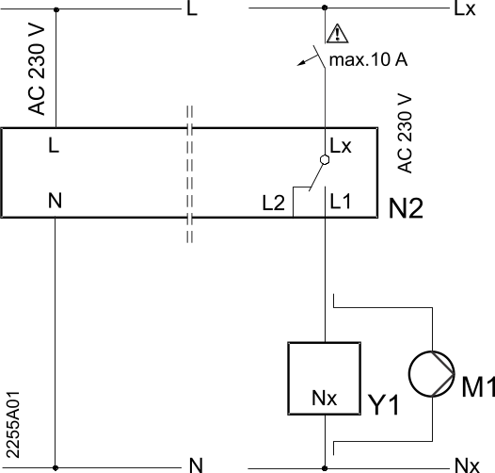
  L | Live, AC 230 V
  Lx | Live, AC 24…250 V
  L1 | N.O. contact, AC 24…250 V / 8 (3) A
  L2 | N.C. contact, AC 24…250 V / 8 (3) A
  M1 | Circulating pump
  N | Neutral conductor
  Nx | Neutral conductor
  N2 | Receiver RCR100/433
  Y1 | Actuating device

 L – N AC 230 V / Lx – Nx AC 24…250 V

Issued by  Siemens Switzerland Ltd  Building Technologies Division  International Headquarters  Gubelstrasse 22  CH-6301 Zug  Tel. +41 41-724 24 24  www.siemens.com/buildingtechnologies | © Siemens Switzerland Ltd, 2017  Technical specifications and availability subject to change without notice.

